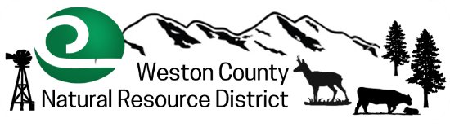
Septic Maintenance Cost Share Program
Application and Agreement
Providing leadership in conserving the natural resources in Weston County by
providing information, education and technical assistance to meet the needs of our users.

Applicant _____________________________________________________________________

Address of Septic System _________________________________________________________

Mailing Address ________________________________________________________________

Phone ________________________________________________________________________

Email _________________________________________________________________________

I, _____________________________________________ agree to participate in the Weston County Natural Resource District (WCNRD) Septic System Maintenance Cost-Share program. I understand that applications shall be considered on a first come first served basis, subject to budget availability.

As a participant in the Septic Maintenance Program, I am required to:

- Complete and submit this application to the Conservation District.

- Obtain approval from Weston County Natural Resource District before work is initiated.

- After approval, contact and schedule work with the contractor.

- Be sure to get the Checklist completed by the contractor following maintenance.

- After contractor has been paid in full, return by 1st Tuesday of the month:
  - Proof of payment (receipt) to the Conservation District
  - Completed inspection report

Please drop off or mail checklist and receipt to: Weston County Natural Resource District
1225 Washington Blvd. Suite 3
Newcastle WY 82701

Reimbursement of $100.00 will be processed at the next Board meeting.
Questions? Contact Caleb Carter, WCNRD Manager, at 307-746-3264 ext. 111

MUST BE COMPLETED BY APRIL 28, 2023 TO RECEIVE REIMBURSEMENT

